Experiment 2

Name: Veeransh Shah

Reg no: 221070063

PL1 Lab

Aim:

The aim is to write a program in python of implements List comprehensions.

Theory:

List comprehension is an elegant way to define and create lists based on existing lists. List comprehension is generally more compact and faster than normal functions and loops for creating list. However, we should avoid writing very long list comprehensions in one line to ensure that code is user-friendly.

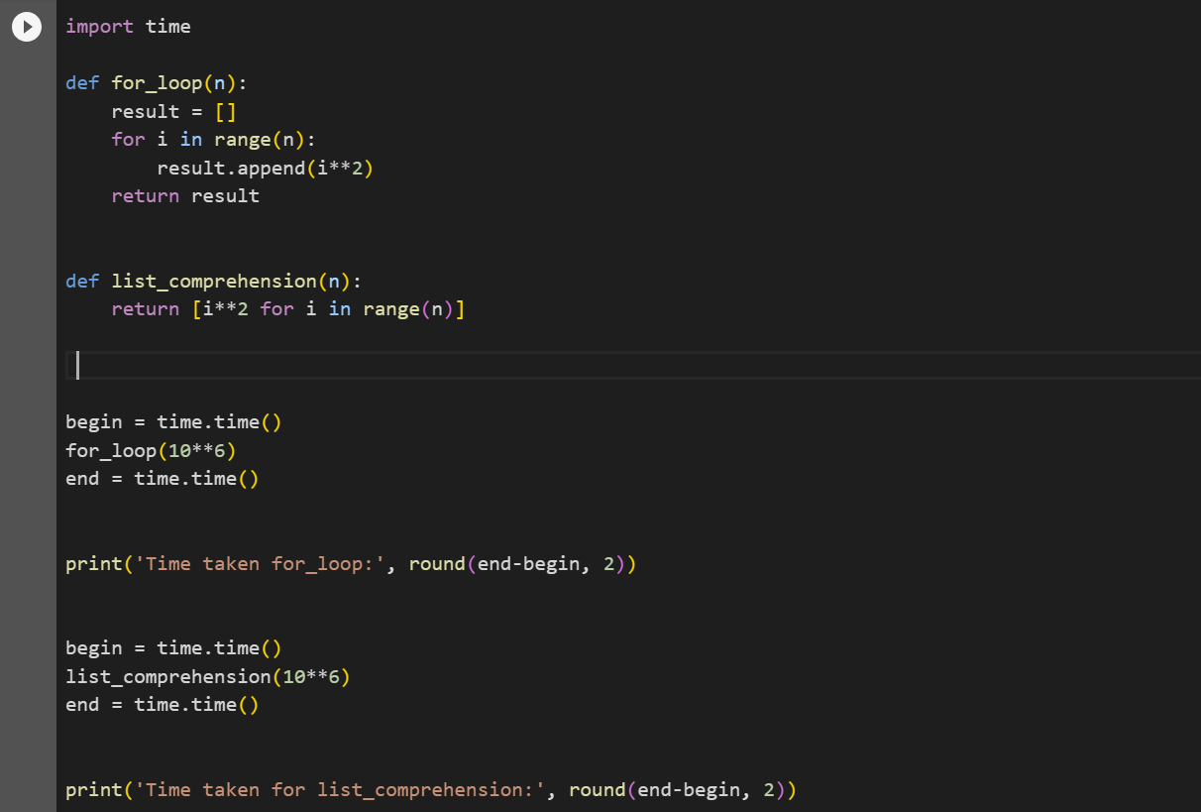

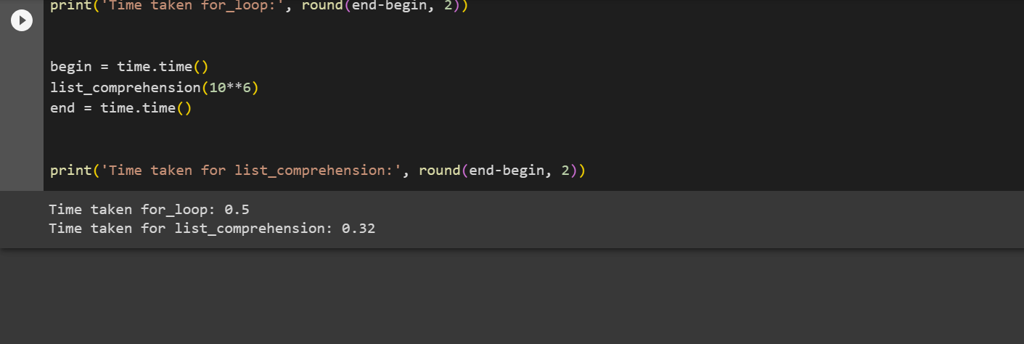

Conclusion:

List comprehension is faster, simpler and reliable in many ways. But, it is usually faster if we want to create a new list out of a list in Python. List comprehension is also considered more pythonic than using for loops or other ways to construct a list in Python.